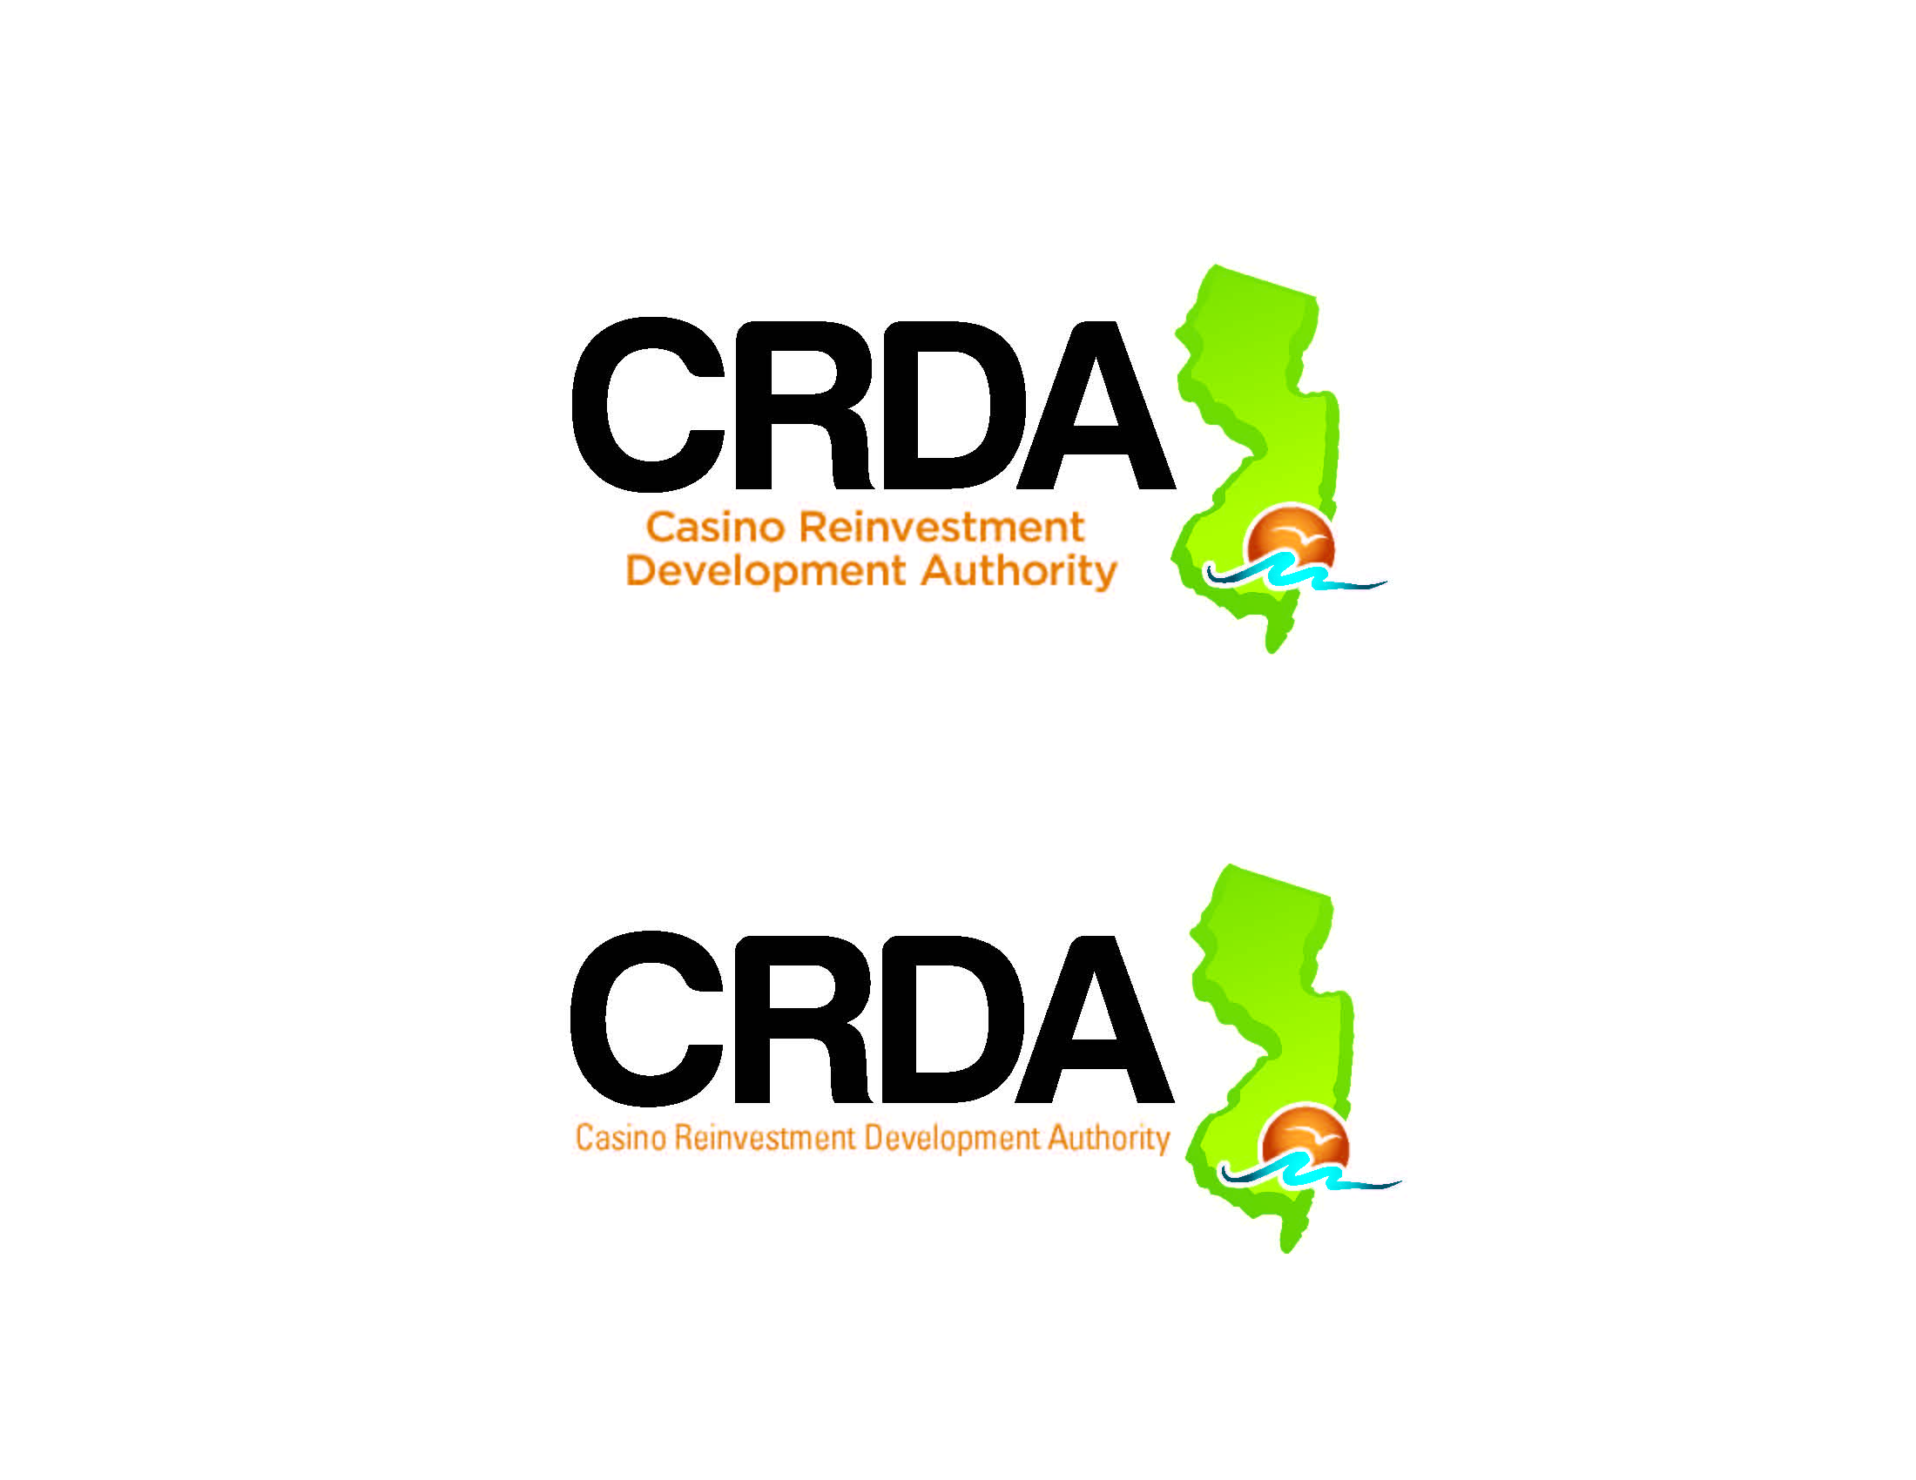

**ZAZA Dispensary, LLP**

**Minor Site Plan Approval with Variances**

**Talking Points**

1. ZAZA Dispensary LLP: Application #***2024-05-3649***, Site Plan Approval to permit the operation of a Class 5 dispensary for the sale of adult use recreational cannabis at the subject property.
2. The property has several pre-existing, non-conforming conditions that are not exacerbated or impacted by the development proposal.
3. A variance pursuant to N.J.S.A. 40:55D-70(c) are required for parking.

1. The Applicant is seeking the Site Plan approval for the class 5 cannabis dispensary in accordance with the Green Zone Redevelopment plan.

1. The site is located at 12 South Virginia Avenue, more formally known as Block 136 Lot 6.
2. The property is located within the Resort Commercial District (RC) and the Green Zone Redevelopment Area which does permit the use.
3. Daniel J. Gallagher, Esq, the attorney for the applicant provided an overview of the proposed development.
4. The Applicant presented the testimony of Dashnay Holmes, who is the Applicant.
5. She described the development proposal and business operations generally.
   1. Ms. Holmes testified regarding operational features for the proposed facility, including security procedures, product storage and inventory management.
   2. The facility will be open from 10 am to 7 pm seven days a week.
   3. All product and cash will be stored in a vault at the facility.
   4. All trash will be stored in a designated area indoors and carted to the curb on collection days.
6. Ms. Holmes testified that the Applicant would agree to the following as a condition of any approval:
   1. Comply with all standards and requirements of the Green Zone Redevelopment Plan, including architectural standards.
   2. Have its security plan approved by the Atlantic City Police Department.
   3. Make all security cameras subject to monitoring by the Atlantic City Police Department.
   4. Comply with all requirements of the CRC.
7. The applicant provided testimony from Mr. Jon Barnhart, P.E., P.P. as to the site the existing nonconforming conditions that exist and will remain.
   1. Front setback, above 35’
   2. Side setback, Above 35’
   3. Building and impervious coverage
   4. All not changing.
8. Mr. Barnhart continued to testify as to the variance relief being requested:

* 1. Section 19:66-5.8(b)1. of the Land Development Rules requires a minimum of one (1) off-street parking space per 300 SF of floor space for retail uses, consequently 9 parking spaces are required for this size structure (2,495 SF),
  2. No spaces are being proposed.
     1. A variance is required.

1. Mr. Barnhart opined that the development proposal will promote the purposes of the Municipal Land Use Law (the “MLUL”). Specifically, he opined that the development proposal will:
   1. Mr. Barnhart testified that the characteristics of the property and the structures lawfully existing thereon present a hardship in providing the required on-site parking.
   2. He noted that there is no opportunity to provide additional parking spaces on-site, and the parking needs for the proposed use are adequately addressed through available public parking in the vicinity of the site.
   3. He also opined that the reduction in the number of signs is an improvement over the existing conditions.
   4. With respect to the negative criteria, Mr. Barnhart testified that the grant of the variances would not have any substantial detriment to the Tourism District Master Plan or Tourism District Land Development Rules

1. Carolyn Feigin, P.E., P.P. was qualified as an expert in professional engineering and Planning, provided testimony on behalf of the Authority.
   1. She acknowledged that the Applicant agreed to address all issues raised in the January 13, 2025 review letter unless otherwise indicated in testimony and testified that she supports approval of the Application.
   2. Plan changes will be submitted for review and approval.
2. A public hearing was conducted on the application on January 16, 2025. One member of the public spoke, Josh Levin.
   1. He asked about parking availability and what the remainder of the building would be used for.
   2. Any change to the use of the remainder of the building would need to come back for additional approvals
   3. No consumption lounge is proposed.
3. Based on the evidence and testimony provided at the hearing and as outlined in the Hearing Officer Report dated January 27, 2025, the Minor Site Plan with a parking variance can be approved based on the testimony provided by the applicant and his professionals and based on solid land use planning testimony.